Test & Evaluation:  Required Leadership  in The Age of Transformation |  |  | Presented by:  Paul McNamara, Founder & CEO  The Sente Group, Inc  pmcnamara@sentegroup.com  Video and answers to questions available soon at www.sentegroup.com/digitaltransformation
Time | Segment | Reflection Questions |  | Notes and Thoughts
00:00 | Introduction | - What are your digital transformation efforts aimed at producing?  - What is the mood of your organization regarding digital transformation? Excited? Curious? Confident? Resolute? Or Cynical? Closed-minded? Small-minded? Skeptical?
1:10 | Dead Cows | - Do you have any speculation about the “invisible” barriers faced by your organization?  - Are there explanations you accept? That you don’t accept? Are people even asking these questions?
2:27 | Prehistoric Hunters  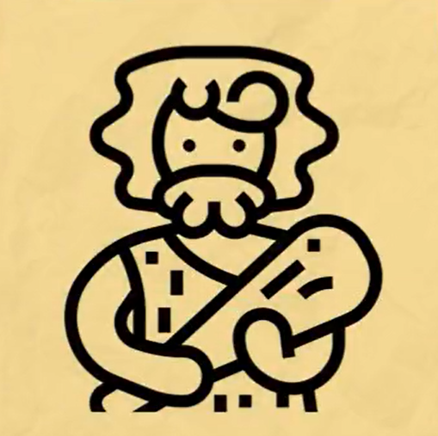 | - Where do you have gaps with tools or culture?  - How do you know which (tools or culture)?  - Where are your teams using their tools like the metaphorical club?
3:34 | Required Leadership  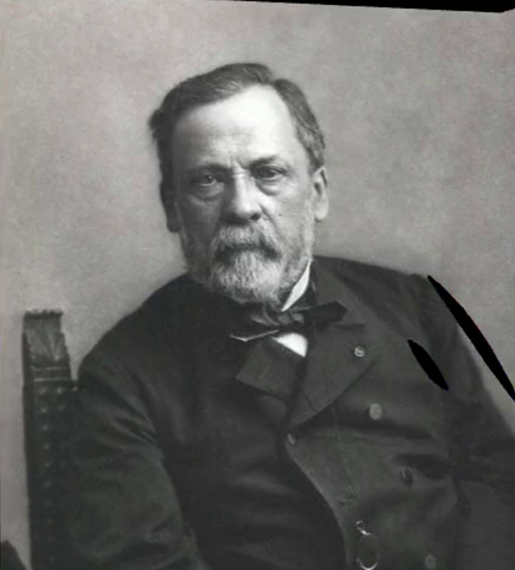 | - What is your situation? What are the threats and their causes? Are you trying to exploit opportunities?  - Do you have a strategy you are confident can cope with the threat or exploit the opportunity? Why or why not?
4:43 | Industrial Revolutions | - What happens if you don’t solve them? For your organization? For you?  - Are you aware of any competitive situations with a digital disrupter?
5:55 | Competitive Forces  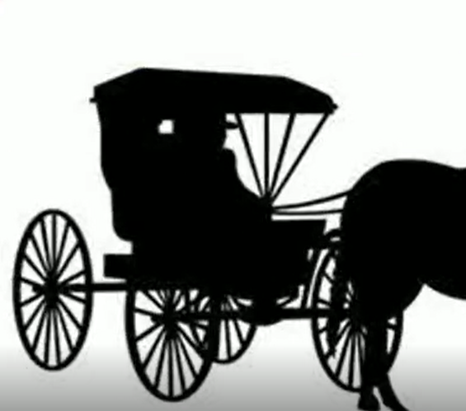 | - Were you surprised how fast things changed for the buggy manufacturers?  - Is your team clear about how unrelenting economic forces can be? Do you accept there is no escaping them?  - Are you using some of the older practices mentioned so far in the video? Are your competitors using these? How will they produce differential results for you?
7:00 | Digital Disruptors | - Will your efforts permanently change the expectations of customers and employees about what’s possible?  - Which of the 4th Industrial Revolution capabilities used by Jobs (offers), Musk (first principles) and Bezos (narratives) is your organization exploiting, if any?
10:10 | Cultural Roots  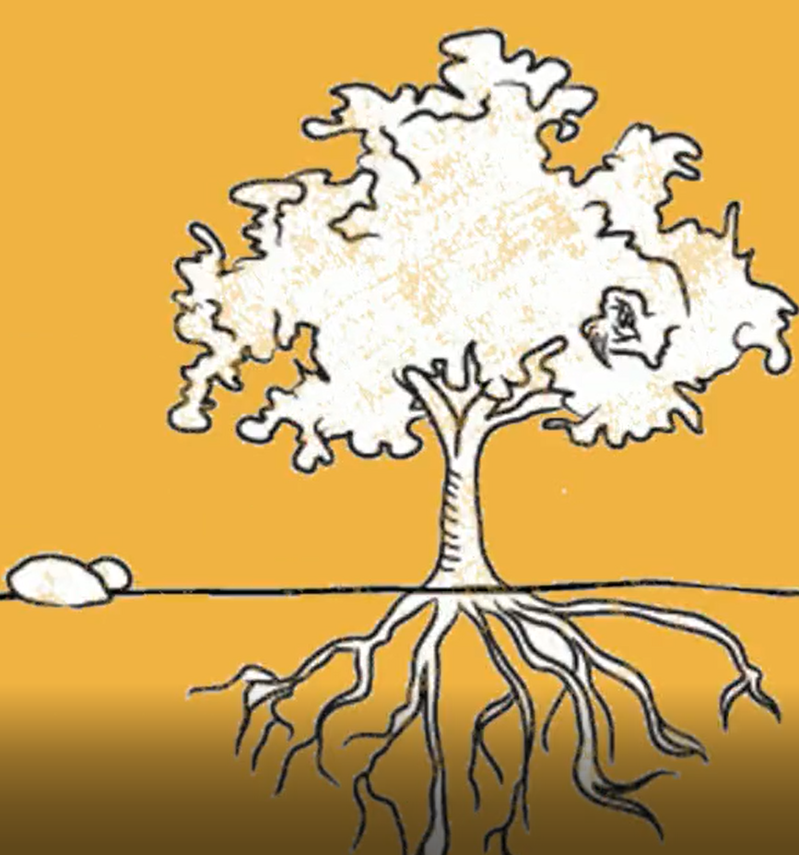 | - How well do your departments communicate and coordinate action with each other?  - Are they currently doing it well enough to produce the innovation, speed and cost objectives required for you to stay competitive?
12:00 | Real World Challenges Example | How many of the challenges discussed here do you have as well? Have you made (or do you need to make) “step change: 2X, 3X” or “incremental: 5%, 15%” improvements in these areas?  - Cost concerns?  - Growth?  - Upgrading technology?  - Planning and coordination?  - Time to market?  - Distractions with non-value-added activity?  - Low utilization of costly equipment?
17:15 | Root Cause of Issues  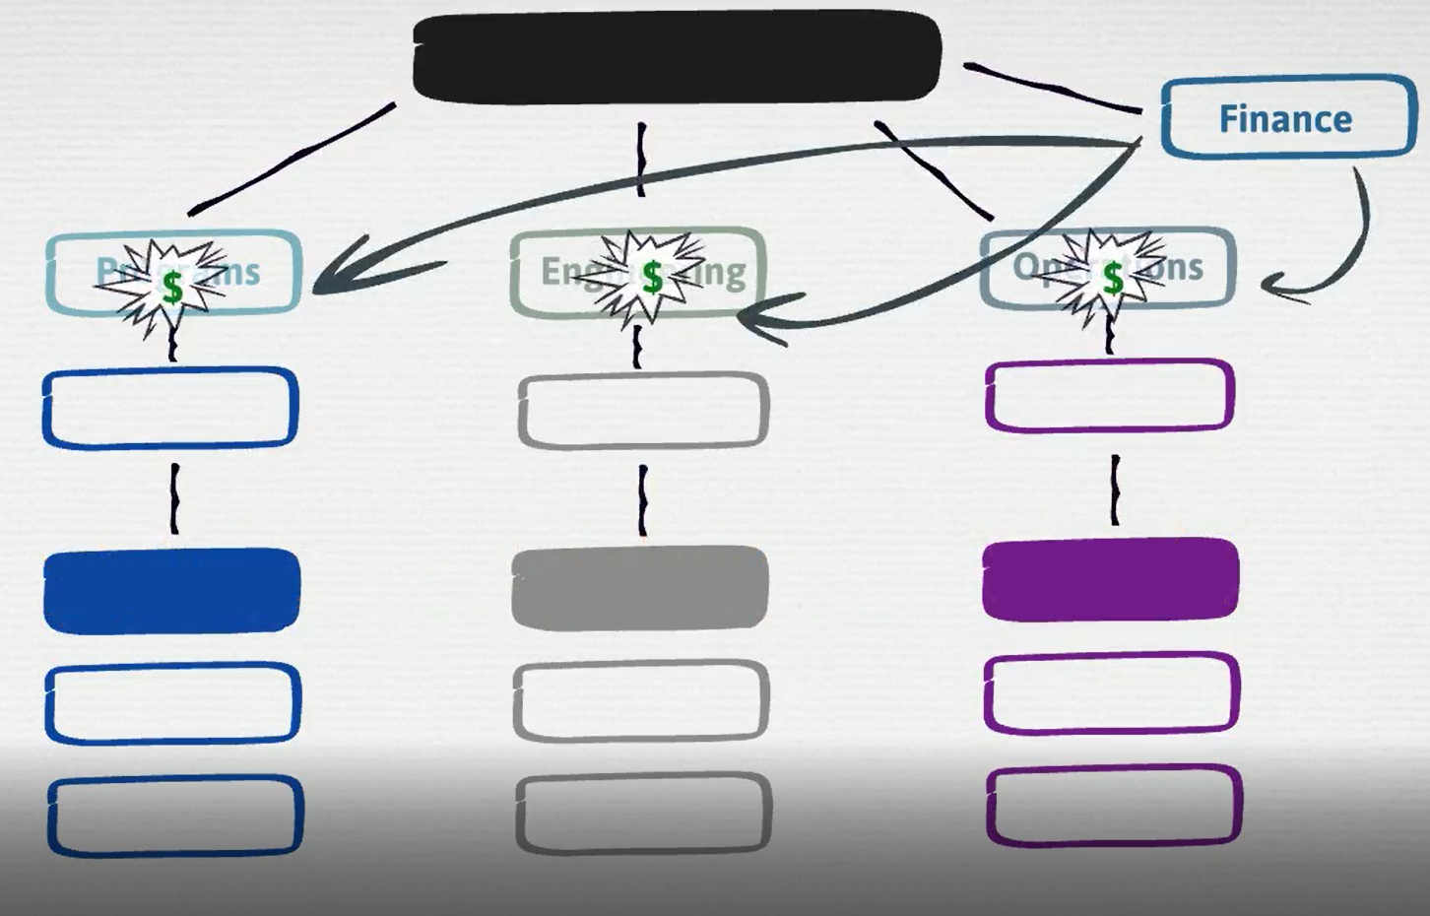 | - What are your organization’s biggest challenges?  - Does your organization produce a level of trust internally and externally that will enable you to hit your innovation, speed, and cost goals? How do you know for sure?  - Does hoarding exist in your organization? Hoarding of equipment? Hoarding of services? Hoarding of information?
19:53 | Grounding the Issues  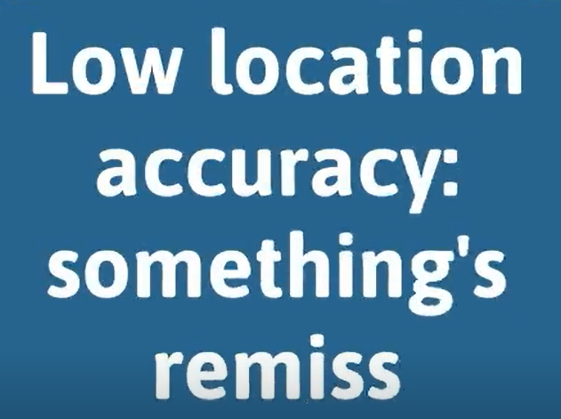 | - What facts do you have to support or negate your claims about trust within your organization?  - Where are your gaps with measuring trust across your organization?
21:37 | Attacking Root Causes  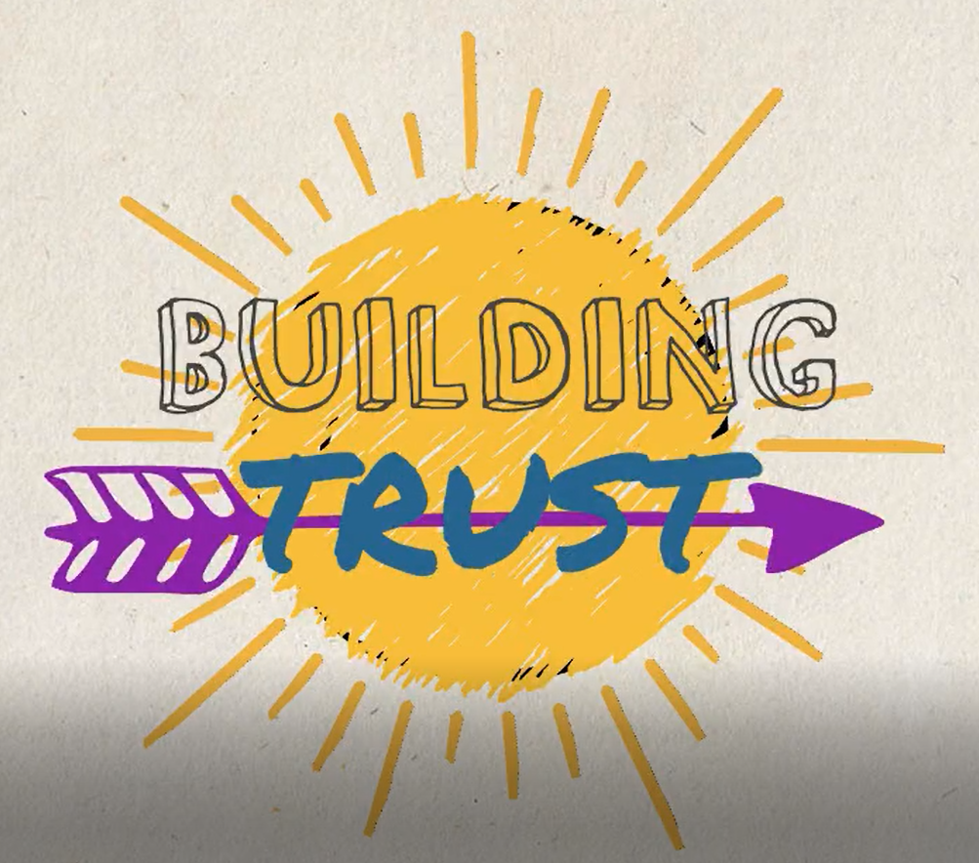 | - What knowledge and practice gaps prevent your organization from building trust to the standards necessary to hit transformation outcomes?
23:57 | Problem Statement and First Principles  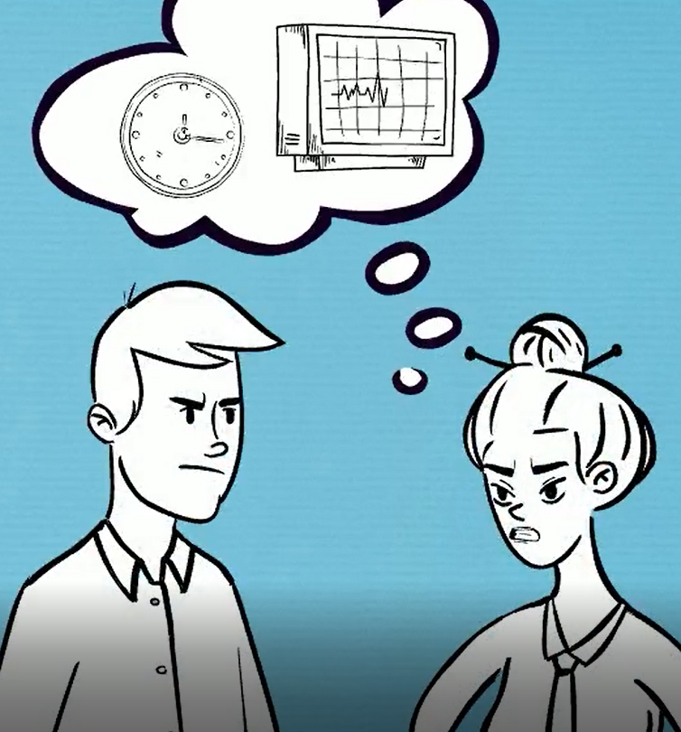 | - Do you know the root cause for your issue including the people or roles that are critical to success?  - Do you consider incentives? Where do your policy and processes rules produce perverse incentives that damage trust?  - Where are costs, other than money, driving negative behaviors or bad moods in your organization? Costs like Time, Energy, and Lost Opportunities?
25:43 | Trust Building Solution  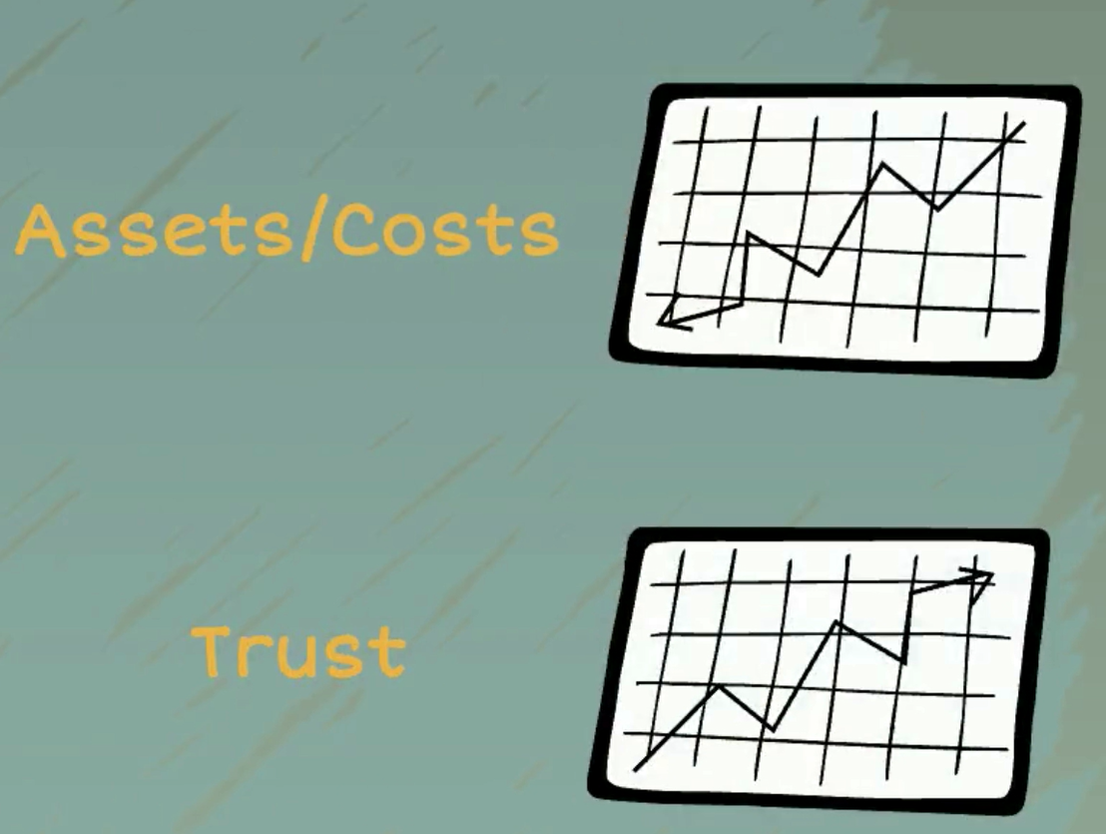 | - Do you have a complete set of trustworthy metrics and narratives that produce effective incentives and actions? How do you know?  - Do people understand how those metrics drive individual and team behaviors that affect outcomes?  - Do you have a practice to make sure actions taken at all levels of your organization align with enterprise objectives?
27:48 | Outcomes / Results | - Are your outcomes measurable and are they broadly accepted / trusted inside your organization?  - What moods do they produce toward your effort? For you? For Others?
32:16 | Culture and Tools  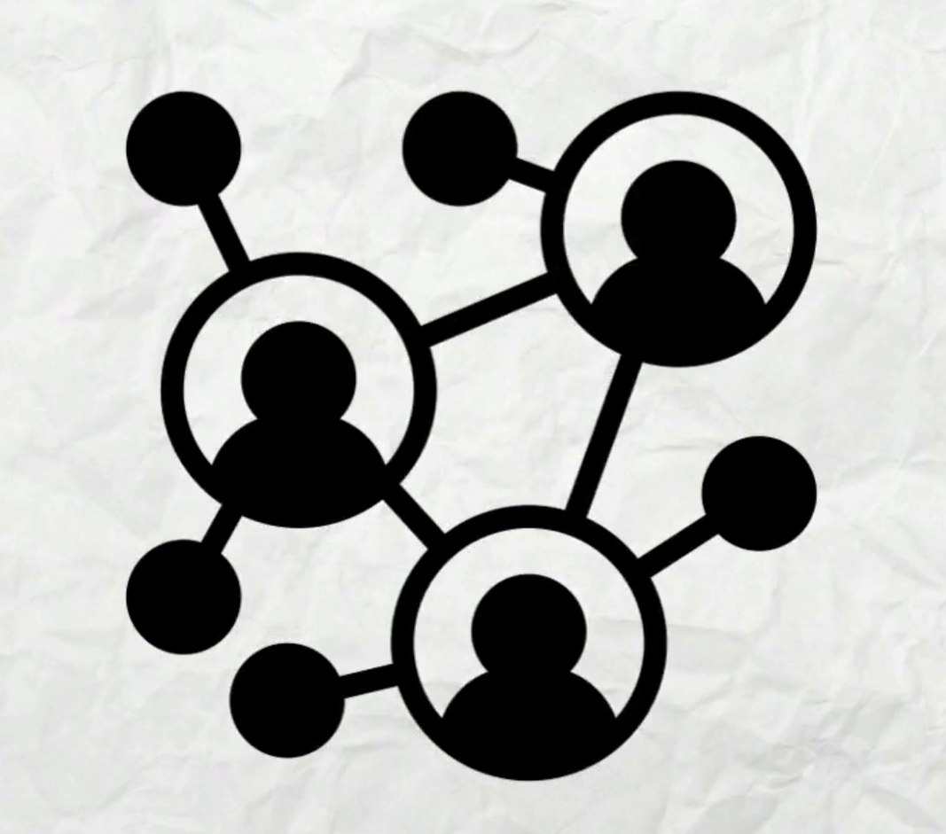 | - Do you have a better sense of how culture affects outcomes?  - Can you see how your tools either reinforce the culture you are after or reinforce the old one that doesn’t work?  - Can you see how tools can enable new behaviors and culture change at scale?
33:55 | Thank you and Full-Length Video Availability | - You can ask me questions directly at pmcnamara@sentegroup.com or can reach me on my mobile at 770-652-8688.  - The full-length video and answers to questions will be published at www.sentegroup.com/digitaltransformation

